SIMATS ENGINEERING (SAVEETHA SCHOOL OF ENGINEERING)
Department of Computer Science and Engineering
ASSESSMENT TOOL 1 – INDIVIDUAL TALK

Course Code: | ITA03 | Course Title: | Mobile computing
CO Assessed: | CO1 | Assessment: | Assessment Tool 3 – INDIVIDUAL TALK
Weightage: | 30 % of CIA | Total Marks: | 20 marks
CO1 Statement: | Analyse the mobile network components, mobile base station, mobile infrastructures and protocols in cellular systems.
Student Name: | D.LALITH KUMAR | Reg. No.: | 192421321
Section / Batch: | B.TECH [ IT ] / 2024 | Date: | 22/07/2026

Code of Conduct

I _______________LALITH KUMAR (192421321)____________ (Name / Reg. No) certify that this submission is my original work and that I have adhered to the guidelines specified for this assessment. I understand that any violation of academic integrity rules will result in disciplinary action.
Signature of the Student: __LALITH KUMAR____

Instructions
- Topic given before the session and students speak on stage.
- Duration: 10 minutes.

INDIVIDUAL TALK

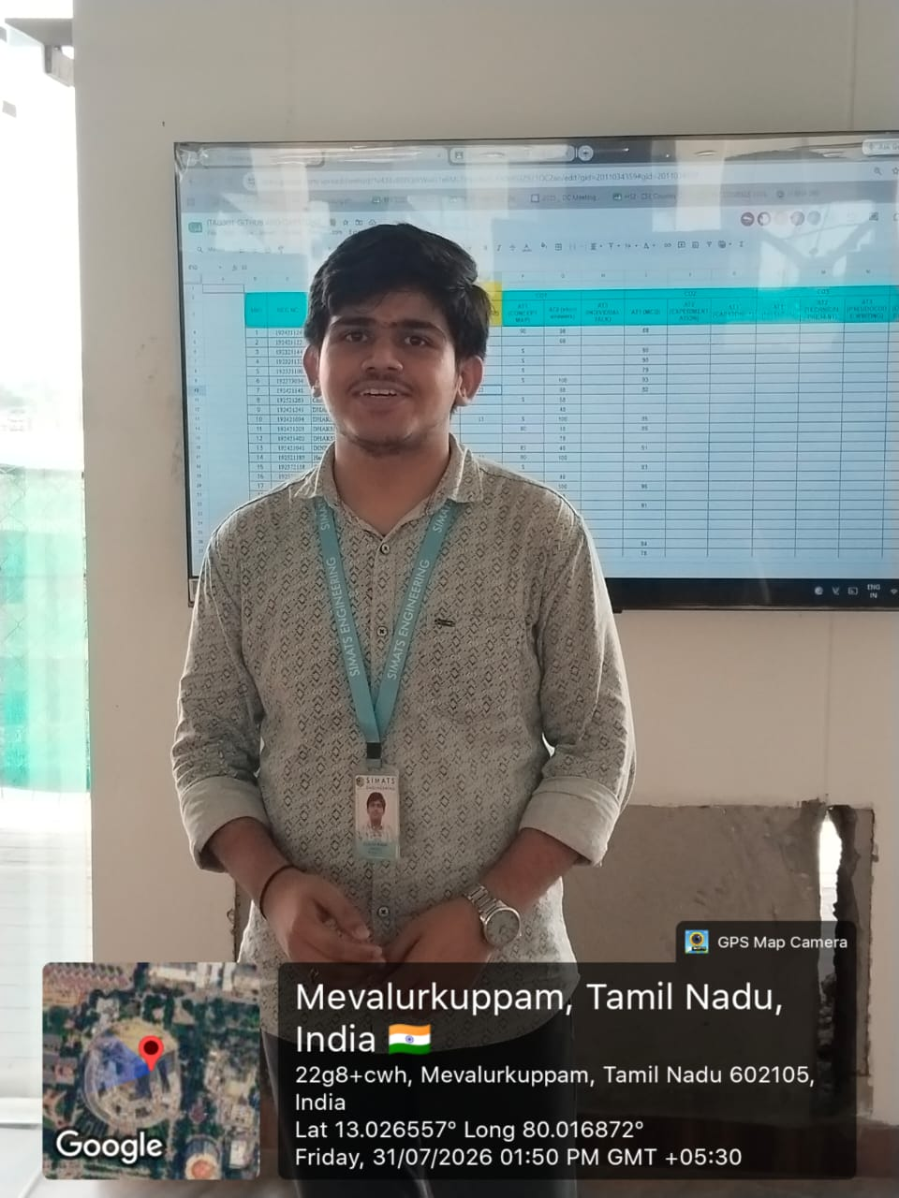

Faculty In-charge | Course Coordinator | Program Director
Signature: _______________ | Signature: _______________ | Signature: _______________
Date: ___________________ | Date: ___________________ | Date: ___________________

